# VISUALIZING AND PREDICTING HEART DISEASE WITH AN INTERACTIVE DASHBOARD

A PROJECT REPORT SUBMITTED BY

**TEAM ID : PNT2022TMID38367**

**TEAM LEADER : VIDYA V**

**TEAM MEMBER : SREE PRIYA R**

### TEAM MEMBER : DEEPASHREE P

### TEAM MEMBER : PUNITHA KAVITHRA G

In partial fulfilment for the award of the degree of

### BACHELOR OF ENGINEERING

in

### COMPUTER SCIENCE AND ENGINEERING

### TAGORE ENGINEERING COLLEGE

### RATHINAMANGALAM, CHENNAI

### ANNA UNIVERSITY::CHENNAI 600 025

**NOV 2022**

**TABLE OF CONTENTS**

#### INTRODUCTION

* 1. Project Overview
  2. Purpose

#### LITERATURE SURVEY

* 1. Existing problem
  2. References
  3. Problem Statement Definition

#### IDEATION & PROPOSED SOLUTION

* 1. Empathy Map Canvas
  2. Ideation & Brainstorming
  3. Proposed Solution
  4. Problem Solution fit

#### REQUIREMENT ANALYSIS

* 1. Functional requirement
  2. Non-Functional requirements

#### PROJECT DESIGN

* 1. Data Flow Diagrams
  2. Solution and Technical architecture
  3. User Stories

#### PROJECT PLANNING & SCHEDULING

* 1. Sprint Planning & Estimation
  2. Sprint Delivery Schedule
  3. Reports from JIRA

#### CODING & SOLUTIONING (Explain the features added in the project along with code)

* 1. Feature 1
  2. Feature 2
  3. Database Schema (if Applicable)

#### TESTING

* 1. Test Cases
  2. User Acceptance Testing

#### RESULTS

* 1. Performance Metrics

#### ADVANTAGES & DISADVANTAGES

1. **CONCLUSION**

#### FUTURE SCOPE

1. **APPENDIX**

Source Code

GitHub & Project Demo Link

#### 1.INTRODUCTION

Heart disorder has created a whole lot of extreme concerned among researches; one of the primary challenges in coronary heart disease is accurate detection and finding presence of it inner a human. Early techniques have no longer been a lot efficient in locating it even medical professor are not a lot green sufficient in predicating the heart ailment. There are various medical contraptions available in the marketplace for predicting coronary heart disease there are two principal issues in them, the first one is that they're very lots steeply-priced and second one is that they are no longer correctly capable of calculate the threat of coronary heart sickness in human. According to trendy survey conducted by using WHO, the scientific expert able to correctly predicted best 67% of coronary heart sickness so there's a huge scope of research in place of predicating coronary heart disease in human with development in computer technology has added good sized possibilities in exceptional regions, medical technological know-how is one of the fields in which the device of computer science may be used. In software regions of pc science varies from metrology to ocean engineering. Medical technological know-how also used a number of the primary available tools in computer technology; in ultimate decade artificial intelligence has gained its second due to development in computation electricity. Machine Learning is one such tool which is broadly utilized in different domain names as it doesn’t require specific algorithm for exceptional dataset. Reprogrammable capacities of system getting to know carry a whole lot of energy and opens new doorways of opportunities for vicinity like clinical technological know-how medical technological know-how coronary heart ailment is one of the major demanding situations; due to the fact a number of parameters and technicality is involve for accurately predicating this sickness. Machine learning will be a higher preference for reaching high accuracy for predicating not best coronary heart disorder however additionally another illnesses because this vary tool makes use of feature vector and its diverse statistics kinds under numerous circumstance for predicating the heart disease, algorithms which includes Naïve Bayes, Decision Tree, KNN, Neural Network, are used to predicate danger of heart sicknesses every algorithm has its specialty consisting of Naive Bayes used possibility for predicating coronary heart ailment, whereas decision tree is used to provide classified record for the heart ailment, while the Neural Network provides opportunities to minimize the mistake in predication of heart disorder. All those techniques are the usage of vintage patient report for purchasing predication about new affected person. This predication machine for coronary heart ailment helps medical doctors to are expecting heart disorder within the early stage of sickness resulting in saving millions of existence.

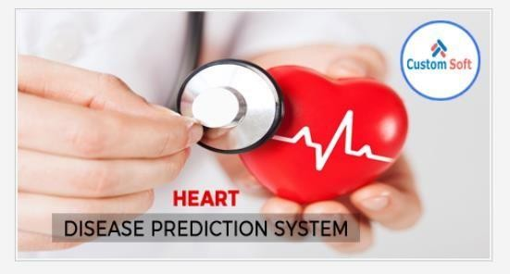

#### 

#### symtoms of heart attacks

1. Chest Pain: The maximum commonplace signal of a coronary heart attack is chest pain. It mainly takes place purpose of the blockage of the coronary vessel of the frame due to the plaque.
2. Arms pain: The ache typically begins within the chest and circulate in the direction of the arm mainly left arm.
3. Low in oxygen: Because of the plaque the extent of oxygen drops within the body and causes the dizziness and loss of stability.
4. Tiredness: this purpose for fatigues way easy chores come to be harder to do.
5. Excessive Sweating: Another not unusual symptom is sweating.
6. Heart disease prediction
7. Diabetics: In this, the patients have a heart price of ~ 100 bpm and also once in a while having a heart rate of 130bpm.
8. Bradycardia: In this, the patient will have a slower heartbeat of 60 bpm.
9. Cerebrovascular Disease: The affected person could have a excessive heart fee than regular typically of two hundred bpm and better than this could cause a Heart assault.

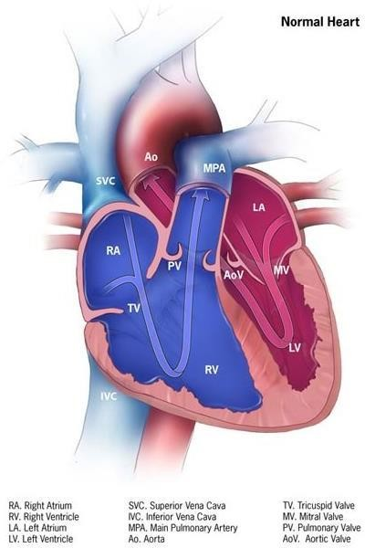

This survey paper is devoted for huge scope survey within the discipline of gadget mastering approach in heart disorder. Later part of this survey paper will discusses approximately diverse machine studying set of rules for coronary heart disease and their relative contrast on the numerous parameter. It additionally shows destiny prospectus of device mastering set of rules in coronary heart ailment. This paper also does a deep analysis on utilization of deep learning in discipline of predicting heart disease.

#### PROJECT OVERVIEW

Several experiments are carried out on clinical statistics sets the usage of a couple of classifiers and features choice techniques. There is little studies at the classification of the heart disease dataset. Many of them show desirable type accuracy. Proposed a hybrid technique in which system getting to know algorithms, Support Vector Machine (SVM) and Genetic Algorithm (G.A), are efficiently combined with the wrapper approach. The LIBSVM and the WEKA statistics mining tool are used to analyze the effects of this technique. Five statistics sets (Iris, diabetes disorder, breast cancer sickness, coronary heart disorder and hepatitis) are gathered from the Irvine UC gadget gaining knowledge of repository for this test. After applying the hybrid GA and SVM approach, an accuracy of 84.07% is acquired for coronary heart ailment. For all diabetes information, 78.26% accuracy is done. The accuracy for breast most cancers is 76.20%. The 86.12% accuracy is the result of hepatitis disease.

Coronary artery disease is detected and monitored with the aid of the proposed gadget. Cleveland Heart records are taken from the UCI. This dataset includes 303 cases and 76 attributes/functions. Thirteen features are used out of 76 capabilities. Two tests with three algorithms: Bayes Naive, Support vector gadget, and Functional Trees FT are executed for detection functions. The WEKA device is used for detection. After checking out the Holdout test, the 88.03% accuracy is finished the use of the SVM technique. In the move-validation test, SVM and Bayes internet offer eighty 3.08% accuracy. The accuracy of 81.5 % is executed after the usage of FT. The 7 high- quality capabilities are selected the usage of the Best First selection algorithm. For validation, cross-validation exams are used. By making use of the take a look at to the 7 excellent functions decided on, Bayes Naive achieved eighty 4.05% accuracy, SVM offers 85.01% accuracy and FT classifies 84.05% efficaciously.

#### 2.PURPOSE

We purpose to design an give up to cease analytical model for prediction of heart sickness where inside the final diagnosis we use a complete of 14 attributes to expect the hazard chance of cardio-vascular disorder in patients body. We have a tendency to make our approach quite sturdy and scalable. It have to accomplish the centered purpose of information science studies To resolve real world eventualities (ex. Estimating the pattern and trends of coronary heart disease in a area of a rustic).

# 2.LITERATURE SURVEY

There are 35 studies papers that discover the computational strategies to predict heart illnesses. The summaries of them were offered in a nutshell. Shaikh Abdul Hannan . used a Radia Basis Function(RBF) to predict the scientific prescription for coronary heart disorder. About 300 patient’s facts have been accumulated from the Sahara Hospital, Aurangabad. RBFNN (Radial Basis Function– Neural Network) may be described as a 3-layer feed ahead structure. The three layers are the enter layer, hidden layer and output layer. The hidden layer consists of a number of RBF units (nh) and bias (bk). Each neuron at the hidden layer uses a radial foundation characteristic as a nonlinear switch characteristic to perform on the enter statistics. The most often used RBF is often a Gaussian function. Designing a RBFNN entails choosing centers, number of hidden layer gadgets, width and weights. The diverse approaches of choosing the centers are random subset choice, k-manner clustering and others. The method was implemented in MATLAB. Obtained outcomes display that radial basis feature can be effectively used (with an accuracy of 90 to 97%) for prescribing the drugs for coronary heart disease.

AH Chen provided a heart ailment prediction system which can useful resource doctors in predicting coronary heart disease repute based on the clinical information of patients. Thirteen crucial clinical capabilities such as age, sex, chest pain kind have been selected. An synthetic neural network algorithm turned into used for classifying coronary heart disorder based totally on Those medical features. Data was collected from device gaining knowledge of repository of UCI. The artificial neural network version contained three layers i.E. The input layer, the hidden layer and the output layer having thirteen neurons, 6 neurons and 2 neurons respectively. Learning Vector Quantization (LVQ) changed into used in this observe. LVQ is a unique case of an artificial neural community that applies a prototype-based supervised category set of rules. C programming language was used as a tool to enforce coronary heart ailment category and prediction skilled via synthetic neural network. The system become advanced in C and C# surroundings. The accuracy of the proposed approach for prediction is near to 80%

Mrudula Gudadhe presented a selection help machine for coronary heart sickness type. Support vector system (SVM) and synthetic neural network (ANN) had been the main strategies used in this machine. A multilayer perceptron neural network (MLPNN) with three layers turned into hired to increase a choice assist gadget for the diagnosis of heart disorder. This multilayer perceptron neural network changed into trained by way of back-propagation set of rules which is computationally technique. Results confirmed that a MLPNN with returned-propagation technique can be successfully used for diagnosing heart ailment.

Manpreet Singh proposed a heart disease prediction machine based on Structural Equation Modelling (SEM) and Fuzzy Cognitive Map (FCM). They used Canadian Community Health Survey (CCHS) 2012 dataset. Here, twenty tremendous attributes have been used. SEM is used to generate the burden matrix for the FCM model which then predicts a opportunity of cardiovascular illnesses. A SEM version is defined with correlation among CCC 121(a variable which defines whether or not the respondent has coronary heart disorder) along with 20 attributes. To construct FCM a weight matrix representing the strength of the causal courting among ideas must be constructed first. The SEM described within the previous segment is now used because the FCM even though they have carried out the required ingredients (i.E. Weight matrix, ideas and causality).80% of the information set was used for education the SEM version and the ultimate 20% for checking out the FCM model. The accuracy acquired by using the use of this version became 74%

Carlos Ordonez has studied association rule mining with the educate and check idea on a dataset for heart disease prediction. Association rule mining has a downside that it produces extremely massive wide variety of regulations most of which are medically inappropriate. Also in standard, affiliation guidelines are mined on the complete records set without validation on an independent sample. In order to remedy this, the writer has devised an set of rules that uses seek constraints to reduce the number of rules. The algorithm then searches for association policies on a schooling set and eventually validates them on an independent check set. The scientific importance of found guidelines is then evaluated with assist, confidence and lift. Search constraints and take a look at set validation considerably reduce the wide variety of affiliation guidelines and convey a hard and fast of rules with high predictive accuracy. These policies constitute valuable clinical expertise.

Prajakta Ghadge have laboured on an smart coronary heart assault prediction device the use of big data. Heart attack wishes to be identified timely and successfully because of its excessive incidence. The objective of this research article is to find a prototype wise coronary heart attack prediction machine that makes use of huge facts and data mining modelling techniques. This gadget can extract hidden information (patterns and relationships) associated with heart disease from a given ancient heart disease database. This method uses Hadoop that's an open-supply software framework written in Java for allotted processing and garage of large datasets. Apache Mahout produced via Apache Software Foundation affords loose implementation of disbursed or scalable machine gaining knowledge of algorithms. Record set with thirteen attributes (age, sex, serum cholesterol, fasting blood sugar and so forth.) become obtained from the Cleveland Heart Database which is to be had at the internet. The patterns had been extracted using 3 strategies i.E. Neural community, Naïve Bayes and Decision tree. The destiny scope of this system objectives at giving greater sophisticated prediction fashions, danger calculation equipment and function extraction gear for other medical dangers.

Asha Rajkumar laboured on analysis of coronary heart disease using classification based totally on supervised device studying. Tanagra device is used to categorise the facts, 10 fold pass validation is used to evaluate the information and the effects are as compared. Tanagra is a loose facts mining software program for academic and\research functions. It indicates numerous records mining strategies from explanatory facts evaluation, statistical learning, system learning and database place. The datasetis split into components, eighty% data is used for education and 20% for trying out. Among the three strategies, Naïve Bayes shows decrease error ratio and takes the least quantity of time.

#### Existing system

The healthcare enterprise collects big quantities of healthcare facts which, unluckily, are not “mined” to find out hidden information. Clinical decisions are frequently made based totally on docs‟ intuition and enjoy instead of at the knowledge wealthy statistics hidden in the database. This exercise ends in unwanted biases, errors and excessive medical.

* + The existing process is very slow to give the result.
  + It is very difficult to find heart disease or not.

#### References

* [https://www.academia.edu](https://www.academia.edu/)
* <https://en.wikipedia.org/wiki/Clinical_data_management>
* https://shodh.inflibnet.ac.in:8080/jspui/bitstream/123456789/4170/3/03\_literature% 20review

#### Problem Statement Definition

From the given data create a Machine Learning model that can predict heart disease most accurately. Previous studies has tested the software of machine getting to know strategies for the prediction and category of Heart disorder. However, these research focus on the precise impacts of specific gadget getting to know strategies and now not at the optimization of those techniques using optimised techniques. In addition, few researchers attempt to use hybrid optimization techniques for an optimized classification of system getting to know. The most proposed research in the literature make the most optimized strategies which includes Particle Swarm Optimization and Ant Colony Optimization with a particular ML method together with SVM, KNN or Random Forest

#### 3.IDEATION & PROPOSED SOLUTION

1. **EMPATHY MAP CANVAS**

**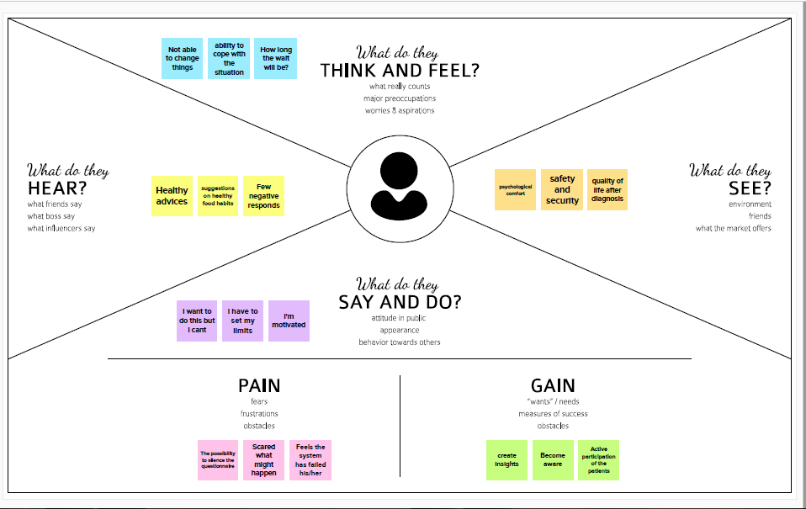**

#### Ideation & Brainstorming

**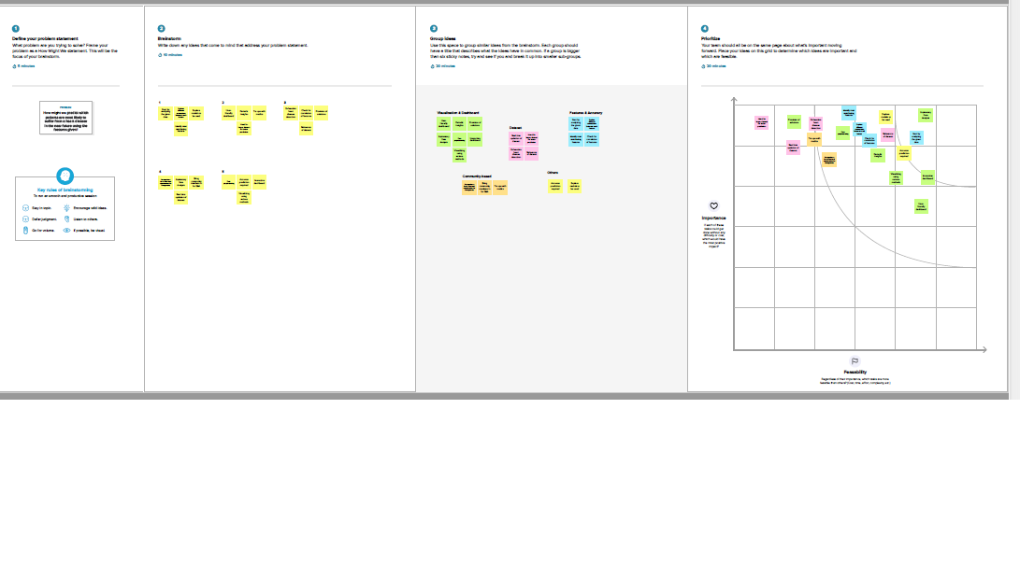**

1. **Proposed Solution**

|  |  |  |
| --- | --- | --- |
| **S.NO** | **Parameter** | **Description** |
| 1. | Problem Statement (Problem to be solved) | * Users create multiple analytical   graphs/charts/Visualizations.   * Using the Analytical Visualizations, build   required Dashboard(s).   * Saving and visualizing the final dashboard in the IBM Cognos Analytics. |
| 2. | Idea/Solution description | Building the following visualizations and drawing appropriate conclusions:   * Average Age for different Chest Pain Types * Average Max heart beat achieved during Chest Pain * Resting Blood Pressure variation with Age * Effect of Existing Heart Diseases on Average Max Hearbeats Achieved * Average age for Chest pain type wrt existing heart disease * Serum Cholesterol levels vs Age plot * Effect of Existing heart disease on Fasting Blood Sugar |
| 3. | Novelty/Uniqueness | * Performing Exploratory Data Analysis on the chosen dataset, scaling and encoding features. * Using various linear classifiers such as SVM, Logistic Regression, and tree models such as Decision Tree, Random   Forest, Gradient Boosting - to compare their performances and improve existing accuracy. |
| 4. | Social Impact/Customer Satisfaction | The leading cause of death in the developed world is heart disease. Therefore, there needs to be work done to help prevent the risks of having a heart attack or stroke |

|  |  |  |
| --- | --- | --- |
| 5. | Business Model (Revenue Model) | Key Partners: 3rd Party Applications,  foundations, Govt. Agencies  Cost Structure: Tech, Investment (fixed)  Revenue Streams: public and private contracts  Customer segments: Middle aged people, older  adults, patients already diagnosed with heart  diseases or related illnesses  Customer Relationship: Customer support,  exclusive channels  Customer channels: website, chatbot  Value proposition: User friendly detection tool  to detect heart diseases at the comfort of one's  home  Key Activities: Attracting new customers,  retaining old ones, providing support, updating  and maintaining data, platform development  and maintenance  Key Resources: Digital platform, loyal customer  base, dedicated team |
| 6. | Scalability of the Solution | There are 2 different ways to accomplish scaling for the proposed solution - Horizontal & Vertical scaling. This solution can be vertically scaled with increasing the capacity of existing dataset with no change in the code. In terms of horizontal scalability, the proposed model can be scaled wider to deal with the traffic. This can be done by increasing the GPUs  (Graphical Processing Units) & TPUs (Tensor Processing Units) and working together as a single logical unit for faster access. |

# 3.PROBLEM SOLUTION FIT

# problem sol.png

**4. REQUIREMENT ANALYSIS**

#### Functional requirements

Following are the functional requirements of the proposed solution.

|  |  |  |
| --- | --- | --- |
| **FR NO** | **Functional Requirement (Epic)** |  |
| FR 1 | User registration | |  | | --- | | Registration through Email | |
| FR 2 | User confirmation | |  | | --- | | Confirmation via Email | |
| FR 3 | Visualizing Data | |  | | --- | | Visualize the trends on heart disease through Dashboard  created using IBM Cognos  Analytics | |
| FR 4 | Generating report | |  | | --- | | Report can be viewed by the users | |

#### Non-Functional requirements

Following are the non-functional requirements of the proposed solution.

|  |  |  |
| --- | --- | --- |
| **NFRNo.** | **Non-Functional** | **Requirement Description** |
| NFR-1 | Usability | |  | | --- | | Provide a simple UI. Actions  can be easily performed by a  few clicks. Features will be  understandable. | |
| NFR-2 | Security | |  | | --- | | 2 step authorization (for register)  Have a backup dataset | |

|  |  |  |  |
| --- | --- | --- | --- |
| NFR-3 | Reliability | |  | | --- | | Error must be low.(Improve accuracy) Must work without glitches | |
| NFR-4 | Performance | |  | | --- | | It is affected by the  implementing algorithm.  Depending on the error metrics  we have to choose an  algorithm with high response  time | |
| NFR-5 | Availability | |  | | --- | | Must be available for the user  24 x 7 without interruptions | |
| NFR-6 | Scalability | |  | | --- | | Should withstand a high number of users and large datasets | |

#### PROJECT DESIGN

* 1. **Data Flow Diagrams**

A Data Flow Diagram (DFD) is a traditional visual representation of the information flows within a system. A neat and clear DFD can depict the right amount of the system requirement graphically. It shows how data enters and leaves the system, what changes the information, and where data is stored.

Data Flow Diagram for Heart Disease Prediction Dashboard:



* 1. **Solution and Technical architecture**

The Deliverable shall include the architectural diagram as below and the information as per the table1 & table 2

Example: Order processing during pandemics for offline mode



Guidelines:

1. Include all the processes (As an application logic / Technology Block)
2. Provide infrastructural demarcation (Local / Cloud)
3. Indicate external interfaces (third party API’s etc.)
4. Indicate Data Storage components / services
5. Indicate interface to machine learning models (if applicable)

Table-1 : Components & Technologies:

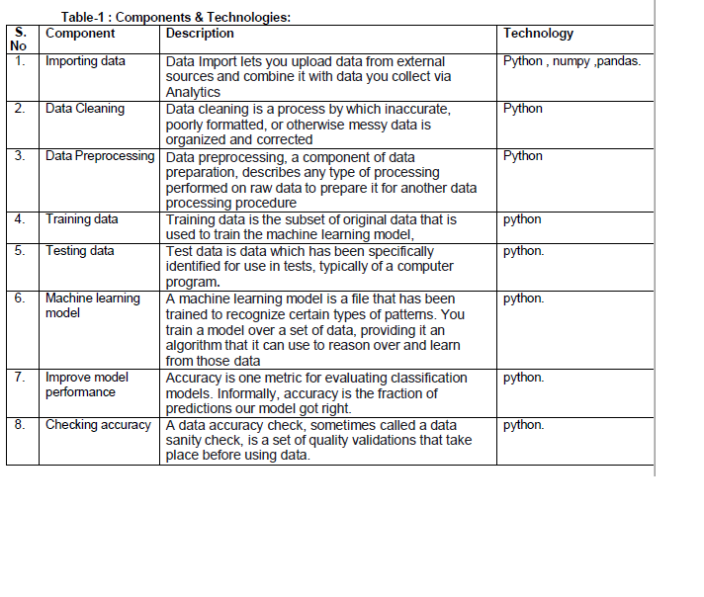

Table-2: Application Characteristics:

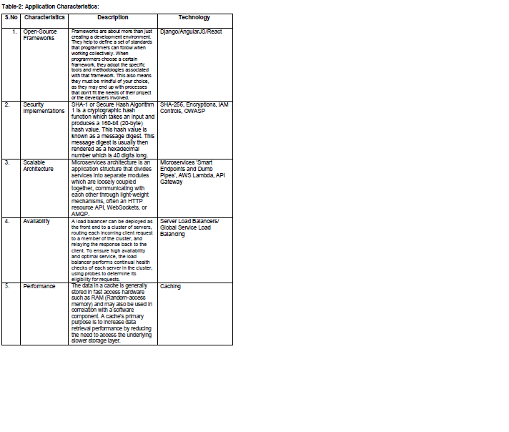

3. User Stories

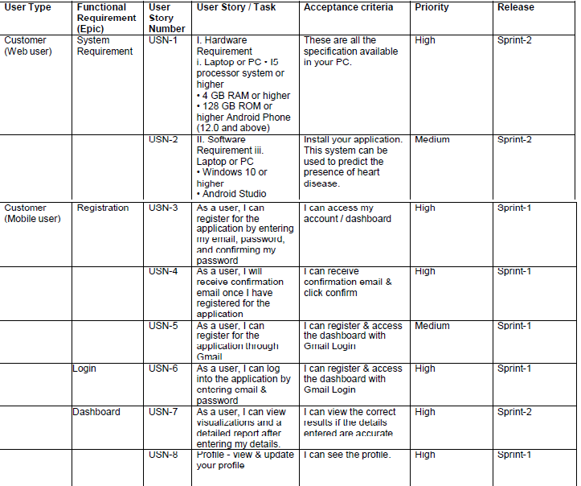

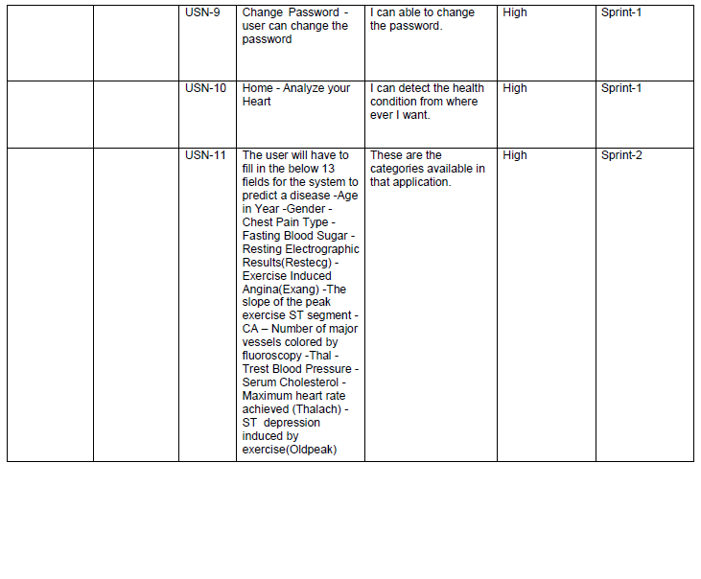

### 6. PROJECT PLANNING & SCHEDULING

**1.** Sprint Planning & Estimation

Product Backlog, Sprint Schedule and Estimation

|  |  |  |  |  |  |  |
| --- | --- | --- | --- | --- | --- | --- |
| Sprint | Functional Requirement  (Epic) | User Story  Number | User Story / Task | Story Points | Priority | Team Members |
| Sprint 1 | |  | | --- | | Data Collection | | USN-1 | |  | | --- | | The dataset is  collected and the  understanding of  dataset is done to  present the  analytics to the  user |   . | 2 | high | |  | | --- | | VIDYA V  SREE PRIYA R  PUNITHA KAVITHRA.G DEEPASHREE  P | |
| Sprint 1 |  | USN-2 | As a user, I will receive confirmation email once I have registered for the  application | 3 | high | VIDYA V  SREE PRIYA. R  PUNITHA KAVITHRA. G DEEPASHREE.P |
| Sprint 2 |  | USN-3 | As a user, I can register for the application through Mobile  number | 8 | High | VIDYA V  SREE PRIYA. R  PUNITHA KAVITHRA. G  DEEPASHREE.P |
| Sprint 1 |  | USN-4 | As a user, I can register for the application  through Gmail | 8 | high | VIDYA V  SREE PRIYA. R  PUNITHA KAVITHRA. G  DEEPASHREE.P |
| Sprint 1 | Login | USN-5 | As a user, I can log into the  application by entering email & password | 8 | high | VIDYA V  SREE PRIYA. R  PUNITHA KAVITHRA. G  DEEPASHREE.P |
| Sprint 2 | Dashboard | USN-6 | Profile - view & update your profile | 8 | High | VIDYA V  SREE PRIYA. R  PUNITHA KAVITHRA. G  DEEPASHREE.P |

Sprint Delivery Schedule :

|  |  |  |  |  |  |  |
| --- | --- | --- | --- | --- | --- | --- |
|  | **Total Story Points** | **Duration** | **Sprint Start Date** | **Sprint End Date (Planned)** | **Story Points Completed (as on Planned End Date)** | **Sprint Release Date (Actual)** |
| **Sprint-1** | 5 | 6 Days | 24 Oct 2022 | 29 Oct 2022 | 5 | 29 Oct 2022 |
| **Sprint-2** | 8 | 6 Days | 05 Nov 2022 | 05 Nov 2022 | 8 | 05 Nov 2022 |
| **Sprint-3** | 8 | 6 Days | 12 Nov 2022 | 12 Nov 2022 | 8 | 12 Nov 2022 |
| **Sprint-4** | 16 | 6 Days | 19 Nov 2022 | 19 Nov 2022 | 16 | 19 Nov 2022 |

Velocity

Imagine we have a 10-day sprint duration, and the velocity of the team is 20 (points per

sprint). Let’s calculate the team’s average velocity (AV) per iteration unit (story points per day)



Burndown Chart:

A burn down chart is a graphical representation of work left to do versus time. It is often used in agile software development methodologies such as Scrum. However, burn down charts can be applied to any project containing measurable progress over time.

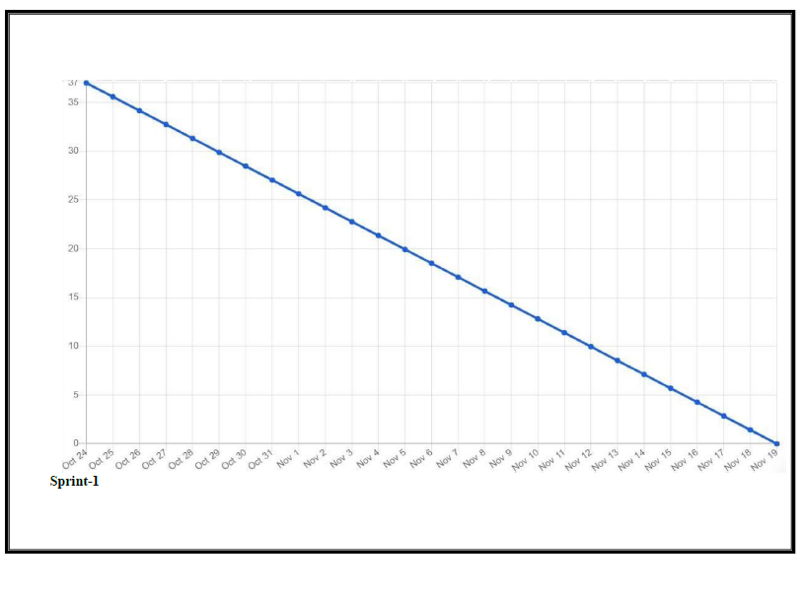

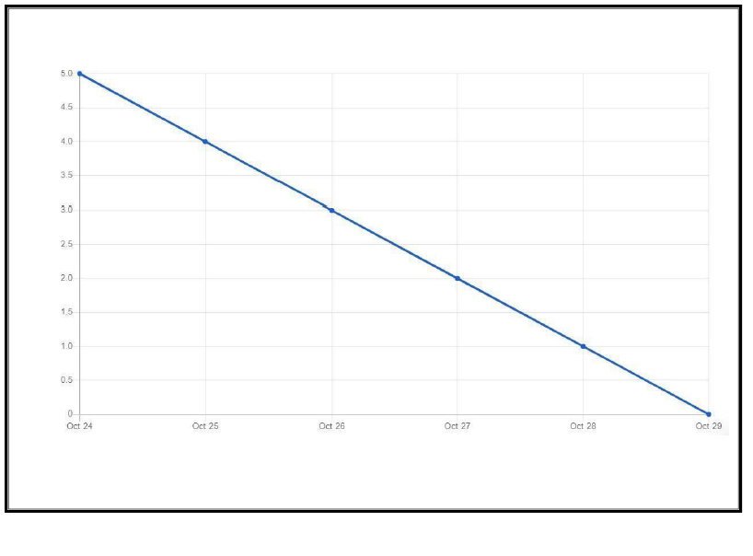

### 7.CODING & SOLUTIONING

FEATURE 1:

**login1.html**

|  |
| --- |
| <!DOCTYPE html |
|  |

|  |
| --- |
| <html lang="en"> |
|  |

|  |
| --- |
| <head> |
|  |

|  |
| --- |
| <meta charset="UTF-8"> |
|  |

|  |
| --- |
| <meta name="viewport" content="width=device-width, initial-scale=1.0"> |
|  |

|  |
| --- |
| <title>Login </title> |
|  |

|  |
| --- |
| <link rel="stylesheet" href="Style1.css"> |
|  |

|  |
| --- |
| <link rel="stylesheet" href="https://cdnjs.cloudflare.com/ajax/libs/font-awesome/5.15.3/css/all.min.css"/> |
|  |

|  |
| --- |
| </head> |
|  |

|  |
| --- |
| <body> |
|  |

|  |
| --- |
| <div class="wrapper"> |
|  |

|  |
| --- |
| <header>Login </header> |
|  |

|  |
| --- |
| <form action="#"> |
|  |

|  |
| --- |
| <div class="field email"> |
|  |

|  |
| --- |
| <div class="input-area"> |
|  |

|  |
| --- |
| <input type="text" placeholder="Email Address"> |
|  |

|  |
| --- |
| <i class="icon fas fa-envelope"></i> |
|  |

|  |
| --- |
| <i class="error error-icon fas fa-exclamation-circle"></i> |
|  |

|  |
| --- |
| </div> |
|  |

|  |
| --- |
| <div class="error error-txt">Email can't be blank</div> |
|  |

|  |
| --- |
| </div> |
|  |

|  |
| --- |
| <div class="field password"> |
|  |

|  |
| --- |
| <div class="input-area"> |
|  |

|  |
| --- |
| <input type="password" placeholder="Password"> |
|  |

|  |
| --- |
| <i class="icon fas fa-lock"></i> |
|  |

|  |
| --- |
| <i class="error error-icon fas fa-exclamation-circle"></i> |
|  |

|  |
| --- |
| </div> |
|  |

|  |
| --- |
| <div class="error error-txt">Password can't be blank</div> |
|  |

|  |
| --- |
| </div> |
|  |

|  |
| --- |
| <div class="pass-txt"><a href="#">Forgot password?</a></div> |
|  |

|  |
| --- |
| <input type="submit" value="Login"> |
|  |

|  |
| --- |
| </form> |
|  |

|  |
| --- |
| <div class="sign-txt">New User? <a href="signup1.html">Signup now</a></div> |
|  |

|  |
| --- |
| </div> |
|  |

|  |
| --- |
|  |
|  |

|  |
| --- |
|  |
|  |

|  |
| --- |
| <script src="script1.js"></script> |
|  |

|  |
| --- |
|  |
|  |

|  |
| --- |
|  |
|  |

|  |
| --- |
| </body> |
|  |

</html>

# index.html:

|  |
| --- |
| <html lang="en"> |
|  |

|  |
| --- |
| <head> |
|  |

|  |
| --- |
| <meta charset="UTF-8"> |
|  |

|  |
| --- |
| <meta http-equiv="X-UA-Compatible" content="IE=edge"> |
|  |

|  |
| --- |
| <meta name="viewport" content="width=device-width, initial-scale=1.0"> |
|  |

|  |
| --- |
| <title>Home Page</title> |
|  |

|  |
| --- |
| <link href=<link href="https://cdn.jsdelivr.net/npm/bootstrap@5.2.0/dist/css/bootstrap.min.css" rel="stylesheet" integrity="sha384-gH2yIJqKdNHPEq0n4Mqa/HGKIhSkIHeL5AyhkYV8i59U5AR6csBvApHHNl/vI1Bx" crossorigin="anonymous"> |
|  |

|  |
| --- |
| <link rel="stylesheet" href="nav.css"> |
|  |

|  |
| --- |
| </head> |
|  |

|  |
| --- |
| <body> |
|  |

|  |
| --- |
| <div class=""> |
|  |

|  |
| --- |
| <img src="Untitled.png" alt="img"> |
|  |

|  |
| --- |
|  |
|  |

|  |
| --- |
| </div> |
|  |

|  |
| --- |
| <div> |
|  |

|  |
| --- |
| <nav class="navbar" > |
|  |

|  |
| --- |
|  |
|  |

|  |
| --- |
| <span class="logo" href="#"></span> |
|  |

|  |
| --- |
| <h1><center>HEART DISEASE PREDICTION</center></h1> |
|  |

|  |
| --- |
| <div class="topnav"> |
|  |

|  |
| --- |
|  |
|  |

|  |
| --- |
| <a href="Story.html">Story</a> |
|  |

|  |
| --- |
| <a href="Report.html">Report</a> |
|  |

|  |
| --- |
| <a href="dashboard.html">Dashboard</a> |
|  |

|  |
| --- |
|  |
|  |

|  |
| --- |
|  |
|  |

|  |
| --- |
| </div> |
|  |

|  |
| --- |
|  |
|  |

|  |
| --- |
|  |
|  |

|  |
| --- |
| </form> |
|  |

|  |
| --- |
| </div> |
|  |

|  |
| --- |
| <!-- Navbar content --> |
|  |

|  |
| --- |
| </nav> |
|  |

|  |
| --- |
| </div> |
|  |

|  |
| --- |
| </body> |
|  |

</html>

# home.css:

|  |
| --- |
| <!--PNT2022TMID01375--> |
|  |

|  |
| --- |
| <html lang="en"> |
|  |

|  |
| --- |
| <head> |
|  |

|  |
| --- |
| <meta charset="UTF-8"> |
|  |

|  |
| --- |
| <meta http-equiv="X-UA-Compatible" content="IE=edge"> |
|  |

|  |
| --- |
| <meta name="viewport" content="width=device-width, initial-scale=1.0"> |
|  |

|  |
| --- |
| <title>Home Page</title> |
|  |

|  |
| --- |
| <link href=<link href="https://cdn.jsdelivr.net/npm/bootstrap@5.2.0/dist/css/bootstrap.min.css" rel="stylesheet" integrity="sha384-gH2yIJqKdNHPEq0n4Mqa/HGKIhSkIHeL5AyhkYV8i59U5AR6csBvApHHNl/vI1Bx" crossorigin="anonymous"> |
|  |

|  |
| --- |
| <link rel="stylesheet" href="nav.css"> |
|  |

|  |
| --- |
| </head> |
|  |

|  |
| --- |
| <body> |
|  |

|  |
| --- |
| <div class=""> |
|  |

|  |
| --- |
| <img src="Untitled.png" alt="img"> |
|  |

|  |
| --- |
|  |
|  |

|  |
| --- |
| </div> |
|  |

|  |
| --- |
| <div> |
|  |

|  |
| --- |
| <nav class="navbar" > |
|  |

|  |
| --- |
|  |
|  |

|  |
| --- |
| <span class="logo" href="#"></span> |
|  |

|  |
| --- |
|  |
|  |

|  |
| --- |
| <h1><CENTER>HEART DISEASE PREDICTION</CENTER></h1> |
|  |

|  |
| --- |
| <div class="topnav"> |
|  |

|  |
| --- |
|  |
|  |

|  |
| --- |
| <a href="good.html">WHY RSSIA</a> |
|  |

|  |
| --- |
| <a href="signup1.html">SIGNUP</a> |
|  |

|  |
| --- |
| <a href="login1.html">LOGIN</a> |
|  |

|  |
| --- |
|  |
|  |

|  |
| --- |
|  |
|  |

|  |
| --- |
| </div> |
|  |

|  |
| --- |
|  |
|  |

|  |
| --- |
|  |
|  |

|  |
| --- |
| </form> |
|  |

|  |
| --- |
| </div> |
|  |

|  |
| --- |
| <!-- Navbar content --> |
|  |

|  |
| --- |
| </nav> |
|  |

|  |
| --- |
| </div> |
|  |

|  |
| --- |
| </body> |
|  |

</html>

**good.html**

|  |
| --- |
| <!DOCTYPE html> |
|  |

|  |
| --- |
| <html> |
|  |

|  |
| --- |
| <head> |
|  |

|  |
| --- |
| <meta name="viewport" content="width=device-width, initial-scale=1"> |
|  |

|  |
| --- |
| <style> |
|  |

|  |
| --- |
| img { |
|  |

|  |
| --- |
| display: block; |
|  |

|  |
| --- |
| margin-left: auto; |
|  |

|  |
| --- |
| margin-right: auto; |
|  |

|  |
| --- |
| } |
|  |

|  |
| --- |
| </style> |
|  |

|  |
| --- |
| </head> |
|  |

|  |
| --- |
| <body> |
|  |

|  |
| --- |
|  |
|  |

|  |
| --- |
|  |
|  |

|  |
| --- |
|  |
|  |

|  |
| --- |
| <img src="why.jpg" alt="Paris" style="width: 75%;"> |
|  |

|  |
| --- |
|  |
|  |

|  |
| --- |
| </body> |
|  |

</html>

### dashboard.html

|  |
| --- |
| <!DOCTYPE html |
|  |

|  |
| --- |
| <html lang="en"> |
|  |

|  |
| --- |
| <head> |
|  |

|  |
| --- |
| <meta charset="UTF-8"> |
|  |

|  |
| --- |
| <meta name="viewport" content="width=device-width, initial-scale=1.0"> |
|  |

|  |
| --- |
| <title>Dashboard</title> |
|  |

|  |
| --- |
| <link href ="https://cdn.jsdelivr.net/npm/bootstrapes.2.1/dist/css/bootstrap.min.css" rel="stylesheet"> |
|  |

|  |
| --- |
| <script src="https://cdn.jsdelive.net/npm/bootstrap 5.2.1/dist/js/bootstrap.bundle.min.js"></script> |
|  |

|  |
| --- |
| </head> |
|  |

|  |
| --- |
| <body> |
|  |

|  |
| --- |
| <div class="container-fluid p-5 be-primary text-white text-center"> |
|  |

|  |
| --- |
|  |
|  |

|  |
| --- |
| <p><iframe src="https://us3.ca.analytics.ibm.com/bi/?perspective=explore&amp;pathRef=.my\_folders%2FData%2BExploration%2FHeart%2BDisease%2BPrediction&amp;closeWindowOnLastView=true&amp;ui\_appbar=false&amp;ui\_navbar=false&amp;shareMode=embedded&amp;subView=model000001848f2c79ea\_00000000" width="320" height="200" frameborder="0" gesture="media" allow="encrypted-media" allowfullscreen=""></iframe></p> |
|  |

|  |
| --- |
| </div> |
|  |

</body>

**story.html**

|  |
| --- |
| <!DOCTYPE html |
|  |

|  |
| --- |
| <html lang="en"> |
|  |

|  |
| --- |
| <head> |
|  |

|  |
| --- |
| <meta charset="UTF-8"> |
|  |

|  |
| --- |
| <meta name="viewport" content="width=device-width, initial-scale=1.0"> |
|  |

|  |
| --- |
| <title>Story</title> |
|  |

|  |
| --- |
| <link href ="https://cdn.jsdelivr.net/npm/bootstrapes.2.1/dist/css/bootstrap.min.css" rel="stylesheet"> |
|  |

|  |
| --- |
| <script src="https://cdn.jsdelive.net/npm/bootstrap 5.2.1/dist/js/bootstrap.bundle.min.js"></script> |
|  |

|  |
| --- |
| </head> |
|  |

|  |
| --- |
| <body> |
|  |

|  |
| --- |
| <div class="container-fluid p-5 be-primary text-white text-center"> |
|  |

|  |
| --- |
|  |
|  |

|  |
| --- |
| <p><iframe src="https://us1.ca.analytics.ibm.com/bi/?perspective=story&amp;pathRef=.my\_folders%2FNew%2Bstory&amp;closeWindowOnLastView=true&amp;ui\_appbar=false&amp;ui\_navbar=false&amp;shareMode=embedded&amp;action=view&amp;sceneId=model000001848b513410\_00000001&amp;sceneTime=15000" width="320" height="200" frameborder="0" gesture="media" allow="encrypted-media" allowfullscreen=""></iframe></p> |
|  |

|  |
| --- |
| </div> |
|  |

</body>

**Style.css**

|  |
| --- |
| @import url('https://fonts.googleapis.com/css2?family=Poppins:wght@300;400;500;600;700;800;900&display=swap'); |
|  |

|  |
| --- |
| \* |
|  |

|  |
| --- |
| { |
|  |

|  |
| --- |
| margin: 0; |
|  |

|  |
| --- |
| padding: 0; |
|  |

|  |
| --- |
| box-sizing: border-box; |
|  |

|  |
| --- |
| font-family: 'Poppins', sans-serif; |
|  |

|  |
| --- |
| color: #45f3ff; |
|  |

|  |
| --- |
|  |
|  |

|  |
| --- |
| } |
|  |

|  |
| --- |
| body{ |
|  |

|  |
| --- |
| width: 100%; |
|  |

|  |
| --- |
| height: 100vh; |
|  |

|  |
| --- |
| display: flex; |
|  |

|  |
| --- |
| align-items: center; |
|  |

|  |
| --- |
| justify-content: center; |
|  |

|  |
| --- |
| background: |
|  |

|  |
| --- |
|  |
|  |

|  |
| --- |
| } |
|  |

|  |
| --- |
| ::selection{ |
|  |

|  |
| --- |
| color: rgb(69, 224, 241); |
|  |

|  |
| --- |
| background: #45f3ff; |
|  |

|  |
| --- |
| } |
|  |

|  |
| --- |
| .wrapper{ |
|  |

|  |
| --- |
| width: 380px; |
|  |

|  |
| --- |
| padding: 40px 30px 50px 30px; |
|  |

|  |
| --- |
| background: #29292b; |
|  |

|  |
| --- |
| border-color: #fff; |
|  |

|  |
| --- |
| border-radius: 5px; |
|  |

|  |
| --- |
| text-align: center; |
|  |

|  |
| --- |
|  |
|  |

|  |
| --- |
|  |
|  |

|  |
| --- |
| } |
|  |

|  |
| --- |
| .wrapper header{ |
|  |

|  |
| --- |
| font-size: 35px; |
|  |

|  |
| --- |
| font-weight: 600; |
|  |

|  |
| --- |
| } |
|  |

|  |
| --- |
| .wrapper form{ |
|  |

|  |
| --- |
| margin: 40px 0; |
|  |

|  |
| --- |
| border-color: #45f3ff; |
|  |

|  |
| --- |
| } |
|  |

|  |
| --- |
| form .field{ |
|  |

|  |
| --- |
| width: 100%; |
|  |

|  |
| --- |
| margin-bottom: 20px; |
|  |

|  |
| --- |
| } |
|  |

|  |
| --- |
| form .field.shake{ |
|  |

|  |
| --- |
| animation: shake 0.3s ease-in-out; |
|  |

|  |
| --- |
| } |
|  |

|  |
| --- |
| @keyframes shake { |
|  |

|  |
| --- |
| 0%, 100%{ |
|  |

|  |
| --- |
| margin-left: 0px; |
|  |

|  |
| --- |
| } |
|  |

|  |
| --- |
| 20%, 80%{ |
|  |

|  |
| --- |
| margin-left: -12px; |
|  |

|  |
| --- |
| } |
|  |

|  |
| --- |
| 40%, 60%{ |
|  |

|  |
| --- |
| margin-left: 12px; |
|  |

|  |
| --- |
| } |
|  |

|  |
| --- |
| } |
|  |

|  |
| --- |
| form .field .input-area{ |
|  |

|  |
| --- |
| height: 50px; |
|  |

|  |
| --- |
| width: 100%; |
|  |

|  |
| --- |
| position: relative; |
|  |

|  |
| --- |
|  |
|  |

|  |
| --- |
| } |
|  |

|  |
| --- |
| form input{ |
|  |

|  |
| --- |
| width: 100%; |
|  |

|  |
| --- |
| height: 100%; |
|  |

|  |
| --- |
| outline: #45f3ff; |
|  |

|  |
| --- |
| padding: 0 45px; |
|  |

|  |
| --- |
| font-size: 18px; |
|  |

|  |
| --- |
| background: none; |
|  |

|  |
| --- |
| caret-color:#45f3ff; |
|  |

|  |
| --- |
| border-radius: 5px; |
|  |

|  |
| --- |
| border: 1px solid #45f3ff; |
|  |

|  |
| --- |
| border-bottom-width: 2px; |
|  |

|  |
| --- |
| transition: all 0.2s ease; |
|  |

|  |
| --- |
| } |
|  |

|  |
| --- |
| form .field input:focus, |
|  |

|  |
| --- |
| form .field.valid input{ |
|  |

|  |
| --- |
| border-color: #45f3ff; |
|  |

|  |
| --- |
| } |
|  |

|  |
| --- |
| form .field.shake input, |
|  |

|  |
| --- |
| form .field.error input{ |
|  |

|  |
| --- |
| border-color: #dc3545; |
|  |

|  |
| --- |
| } |
|  |

|  |
| --- |
| .field .input-area i{ |
|  |

|  |
| --- |
| position: absolute; |
|  |

|  |
| --- |
| top: 50%; |
|  |

|  |
| --- |
| font-size: 18px; |
|  |

|  |
| --- |
| pointer-events: none; |
|  |

|  |
| --- |
| transform: translateY(-50%); |
|  |

|  |
| --- |
| } |
|  |

|  |
| --- |
| .input-area .icon{ |
|  |

|  |
| --- |
| left: 15px; |
|  |

|  |
| --- |
| color: #fff; |
|  |

|  |
| --- |
| transition: color 0.2s ease; |
|  |

|  |
| --- |
| } |
|  |

|  |
| --- |
| .input-area .error-icon{ |
|  |

|  |
| --- |
| right: 15px; |
|  |

|  |
| --- |
| color: #dc3545; |
|  |

|  |
| --- |
| } |
|  |

|  |
| --- |
| form input:focus ~ .icon, |
|  |

|  |
| --- |
| form .field.valid .icon{ |
|  |

|  |
| --- |
| color: #45f3ff; |
|  |

|  |
| --- |
| } |
|  |

|  |
| --- |
| form .field.shake input:focus ~ .icon, |
|  |

|  |
| --- |
| form .field.error input:focus ~ .icon{ |
|  |

|  |
| --- |
| color:#45f3ff ; |
|  |

|  |
| --- |
| } |
|  |

|  |
| --- |
| form input::placeholder{ |
|  |

|  |
| --- |
| color: #bfbfbf; |
|  |

|  |
| --- |
| font-size: 17px; |
|  |

|  |
| --- |
| } |
|  |

|  |
| --- |
| form .field .error-txt{ |
|  |

|  |
| --- |
| color: #dc3545; |
|  |

|  |
| --- |
| text-align: left; |
|  |

|  |
| --- |
| margin-top: 5px; |
|  |

|  |
| --- |
| } |
|  |

|  |
| --- |
| form .field .error{ |
|  |

|  |
| --- |
| display: none; |
|  |

|  |
| --- |
| } |
|  |

|  |
| --- |
| form .field.shake .error, |
|  |

|  |
| --- |
| form .field.error .error{ |
|  |

|  |
| --- |
| display: block; |
|  |

|  |
| --- |
| } |
|  |

|  |
| --- |
| form .pass-txt{ |
|  |

|  |
| --- |
| text-align: left; |
|  |

|  |
| --- |
| margin-top: -10px; |
|  |

|  |
| --- |
| } |
|  |

|  |
| --- |
| .wrapper a{ |
|  |

|  |
| --- |
| color: #45f3ff; |
|  |

|  |
| --- |
| text-decoration: none; |
|  |

|  |
| --- |
| } |
|  |

|  |
| --- |
| .wrapper a:hover{ |
|  |

|  |
| --- |
| text-decoration: underline; |
|  |

|  |
| --- |
| } |
|  |

|  |
| --- |
| form input[type="submit"]{ |
|  |

|  |
| --- |
| height: 50px; |
|  |

|  |
| --- |
| margin-top: 30px; |
|  |

|  |
| --- |
| color: #23242a; |
|  |

|  |
| --- |
| padding: 0; |
|  |

|  |
| --- |
| border: none; |
|  |

|  |
| --- |
| background: #45f3ff; |
|  |

|  |
| --- |
| cursor: pointer; |
|  |

|  |
| --- |
| border-bottom: 2px solid rgba(0,0,0,0.1); |
|  |

|  |
| --- |
| transition: all 0.3s ease; |
|  |

|  |
| --- |
| } |
|  |

|  |
| --- |
| form input[type="submit"]:hover{ |
|  |

|  |
| --- |
| background: #45f3ff; |
|  |

};

**nav.css**

|  |
| --- |
| .navbar{ |
|  |

|  |
| --- |
| position: fixed; |
|  |

|  |
| --- |
| width: 100%; |
|  |

|  |
| --- |
| height: 70px; |
|  |

|  |
| --- |
| left: 0px; |
|  |

|  |
| --- |
| top: 0%; |
|  |

|  |
| --- |
| background-image: url("s1.png"); |
|  |

|  |
| --- |
|  |
|  |

|  |
| --- |
|  |
|  |

|  |
| --- |
| } |
|  |

|  |
| --- |
| body |
|  |

|  |
| --- |
| { |
|  |

|  |
| --- |
| justify-content: center; |
|  |

|  |
| --- |
| align-items: center; |
|  |

|  |
| --- |
| background:#f9fdfe; |
|  |

|  |
| --- |
| width: 100%; |
|  |

|  |
| --- |
| height: 100%; |
|  |

|  |
| --- |
| position: relative; |
|  |

|  |
| --- |
|  |
|  |

|  |
| --- |
| } |
|  |

|  |
| --- |
| img{ |
|  |

|  |
| --- |
| position: fixed; |
|  |

|  |
| --- |
| width: 100%; |
|  |

|  |
| --- |
| height: 106%; |
|  |

|  |
| --- |
| left: 0%; |
|  |

|  |
| --- |
| top: 0%; |
|  |

|  |
| --- |
| } |
|  |

|  |
| --- |
| /\* Add a black background color to the top navigation \*/ |
|  |

|  |
| --- |
| .topnav { |
|  |

|  |
| --- |
| background-image: url("s1.png"); |
|  |

|  |
| --- |
| width: 100%; |
|  |

|  |
| --- |
| height: 70px; |
|  |

|  |
| --- |
| overflow: hidden; |
|  |

|  |
| --- |
| border-top-style: solid; |
|  |

|  |
| --- |
|  |
|  |

|  |
| --- |
| } |
|  |

|  |
| --- |
|  |
|  |

|  |
| --- |
| /\* Style the links inside the navigation bar \*/ |
|  |

|  |
| --- |
| .topnav a { |
|  |

|  |
| --- |
| float: right; |
|  |

|  |
| --- |
| color: BLACK; |
|  |

|  |
| --- |
| height: 70px; |
|  |

|  |
| --- |
| text-align: center; |
|  |

|  |
| --- |
| padding: 14px 16px; |
|  |

|  |
| --- |
| text-decoration: none; |
|  |

|  |
| --- |
| font-size: 20px; |
|  |

|  |
| --- |
| font-weight: bold; |
|  |

|  |
| --- |
|  |
|  |

|  |
| --- |
| } |
|  |

|  |
| --- |
|  |
|  |

|  |
| --- |
| /\* Change the color of links on hover \*/ |
|  |

|  |
| --- |
| .topnav a:hover { |
|  |

|  |
| --- |
| background-color: #ddd; |
|  |

|  |
| --- |
| color: white; |
|  |

|  |
| --- |
|  |
|  |

|  |
| --- |
| } |
|  |

|  |
| --- |
|  |
|  |

|  |
| --- |
| /\* Add a color to the active/current link \*/ |
|  |

|  |
| --- |
| .topnav a.active { |
|  |

|  |
| --- |
| background-color: #23242a; |
|  |

|  |
| --- |
| color: white; |
|  |

|  |
| --- |
| } |
|  |

|  |
| --- |
|  |
|  |

|  |
| --- |
| .container { |
|  |

|  |
| --- |
| background-color: #65fdfb59; |
|  |

|  |
| --- |
| border-radius: 10px; |
|  |

|  |
| --- |
| box-shadow: 0 14px 28px rgba(0,0,0,0.25), |
|  |

|  |
| --- |
| 0 10px 10px rgba(0,0,0,0.22); |
|  |

|  |
| --- |
| position: relative; |
|  |

|  |
| --- |
| overflow: hidden; |
|  |

|  |
| --- |
| top: 222%; |
|  |

|  |
| --- |
| left: 63px; |
|  |

|  |
| --- |
| width: 649px; |
|  |

|  |
| --- |
| max-width: 100%; |
|  |

|  |
| --- |
| min-height: 406px; |
|  |

|  |
| --- |
| } |
|  |

|  |
| --- |
| .button{ |
|  |

|  |
| --- |
| border-radius: 20px; |
|  |

|  |
| --- |
| border: 1px solid #BAF1F6; |
|  |

|  |
| --- |
| background-color: #65fdfb59; |
|  |

|  |
| --- |
| color: white; |
|  |

|  |
| --- |
| font-size: 12px; |
|  |

|  |
| --- |
| font-weight: bold; |
|  |

|  |
| --- |
| padding: 12px 45px; |
|  |

|  |
| --- |
| letter-spacing: 1px; |
|  |

|  |
| --- |
| text-transform: uppercase; |
|  |

|  |
| --- |
| transition: transform 80ms ease-in; |
|  |

|  |
| --- |
| border-color: rgba(255, 0, 0, 0.24); |
|  |

|  |
| --- |
| } |
|  |

|  |
| --- |
| button:active { |
|  |

|  |
| --- |
| transform: scale(0.95); |
|  |

|  |
| --- |
| } |
|  |

|  |
| --- |
|  |
|  |

|  |
| --- |
| button:focus { |
|  |

|  |
| --- |
| outline: none; |
|  |

|  |
| --- |
| } |
|  |

|  |
| --- |
|  |
|  |

|  |
| --- |
| button.ghost { |
|  |

|  |
| --- |
| background-color: 8F78CF; |
|  |

|  |
| --- |
| border-color: rgb(242, 240, 240); |
|  |

|  |
| --- |
| font-size: x-large; |
|  |

|  |
| --- |
| border-radius: 100PX; |
|  |

|  |
| --- |
| } |
|  |

|  |
| --- |
| .head{ |
|  |

|  |
| --- |
| font-size: xx-large; |
|  |

|  |
| --- |
| font-style: IM FELL French Canon SC; |
|  |

|  |
| --- |
| } |
|  |

|  |
| --- |
| .button{ |
|  |

|  |
| --- |
| top: 10%; |
|  |

|  |
| --- |
| left: 10%; |
|  |

|  |
| --- |
|  |
|  |

}

**nav.css.txt**

|  |
| --- |
| .navbar{ |
|  |

|  |
| --- |
| position: fixed; |
|  |

|  |
| --- |
| width: 100%; |
|  |

|  |
| --- |
| height: 75px; |
|  |

|  |
| --- |
| left: 0px; |
|  |

|  |
| --- |
| top: 0%; |
|  |

|  |
| --- |
| background-image: url("s1.png"); |
|  |

|  |
| --- |
|  |
|  |

|  |
| --- |
|  |
|  |

|  |
| --- |
| } |
|  |

|  |
| --- |
| body |
|  |

|  |
| --- |
| { |
|  |

|  |
| --- |
| justify-content: center; |
|  |

|  |
| --- |
| align-items: center; |
|  |

|  |
| --- |
| background:#f9fdfe; |
|  |

|  |
| --- |
| width: 100%; |
|  |

|  |
| --- |
| height: 100%; |
|  |

|  |
| --- |
| position: relative; |
|  |

|  |
| --- |
|  |
|  |

|  |
| --- |
| } |
|  |

|  |
| --- |
| img{ |
|  |

|  |
| --- |
| position: fixed; |
|  |

|  |
| --- |
| width: 100%; |
|  |

|  |
| --- |
| height: 106%; |
|  |

|  |
| --- |
| left: 0%; |
|  |

|  |
| --- |
| top: 0%; |
|  |

|  |
| --- |
| } |
|  |

|  |
| --- |
| /\* Add a black background color to the top navigation \*/ |
|  |

|  |
| --- |
| .topnav { |
|  |

|  |
| --- |
| background-image: url("s1.png"); |
|  |

|  |
| --- |
| width: 100%; |
|  |

|  |
| --- |
| height: 70px; |
|  |

|  |
| --- |
| overflow: hidden; |
|  |

|  |
| --- |
| border-top-style: solid; |
|  |

|  |
| --- |
|  |
|  |

|  |
| --- |
| } |
|  |

|  |
| --- |
|  |
|  |

|  |
| --- |
| /\* Style the links inside the navigation bar \*/ |
|  |

|  |
| --- |
| .topnav a { |
|  |

|  |
| --- |
| float: right; |
|  |

|  |
| --- |
| color: black; |
|  |

|  |
| --- |
| height: 70px; |
|  |

|  |
| --- |
| text-align: center; |
|  |

|  |
| --- |
| padding: 14px 16px; |
|  |

|  |
| --- |
| text-decoration: none; |
|  |

|  |
| --- |
| font-size: 20px; |
|  |

|  |
| --- |
| font-weight: bold; |
|  |

|  |
| --- |
|  |
|  |

|  |
| --- |
| } |
|  |

|  |
| --- |
|  |
|  |

|  |
| --- |
| /\* Change the color of links on hover \*/ |
|  |

|  |
| --- |
| .topnav a:hover { |
|  |

|  |
| --- |
| background-color: #ddd; |
|  |

|  |
| --- |
| color: black; |
|  |

|  |
| --- |
|  |
|  |

|  |
| --- |
| } |
|  |

|  |
| --- |
|  |
|  |

|  |
| --- |
| /\* Add a color to the active/current link \*/ |
|  |

|  |
| --- |
| .topnav a.active { |
|  |

|  |
| --- |
| background-color: #23242a; |
|  |

|  |
| --- |
| color: white; |
|  |

|  |
| --- |
| } |
|  |

|  |
| --- |
|  |
|  |

|  |
| --- |
| .container { |
|  |

|  |
| --- |
| background-color: #65fdfb59; |
|  |

|  |
| --- |
| border-radius: 10px; |
|  |

|  |
| --- |
| box-shadow: 0 14px 28px rgba(0,0,0,0.25), |
|  |

|  |
| --- |
| 0 10px 10px rgba(0,0,0,0.22); |
|  |

|  |
| --- |
| position: relative; |
|  |

|  |
| --- |
| overflow: hidden; |
|  |

|  |
| --- |
| top: 222%; |
|  |

|  |
| --- |
| left: 63px; |
|  |

|  |
| --- |
| width: 649px; |
|  |

|  |
| --- |
| max-width: 100%; |
|  |

|  |
| --- |
| min-height: 406px; |
|  |

|  |
| --- |
| } |
|  |

|  |
| --- |
| .button{ |
|  |

|  |
| --- |
| border-radius: 20px; |
|  |

|  |
| --- |
| border: 1px solid #BAF1F6; |
|  |

|  |
| --- |
| background-color: #65fdfb59; |
|  |

|  |
| --- |
| color: black; |
|  |

|  |
| --- |
| font-size: 12px; |
|  |

|  |
| --- |
| font-weight: bold; |
|  |

|  |
| --- |
| padding: 12px 45px; |
|  |

|  |
| --- |
| letter-spacing: 1px; |
|  |

|  |
| --- |
| text-transform: uppercase; |
|  |

|  |
| --- |
| transition: transform 80ms ease-in; |
|  |

|  |
| --- |
| border-color: rgba(255, 0, 0, 0.24); |
|  |

|  |
| --- |
| } |
|  |

|  |
| --- |
| button:active { |
|  |

|  |
| --- |
| transform: scale(0.95); |
|  |

|  |
| --- |
| } |
|  |

|  |
| --- |
|  |
|  |

|  |
| --- |
| button:focus { |
|  |

|  |
| --- |
| outline: none; |
|  |

|  |
| --- |
| } |
|  |

|  |
| --- |
|  |
|  |

|  |
| --- |
| button.ghost { |
|  |

|  |
| --- |
| background-color: 8F78CF; |
|  |

|  |
| --- |
| border-color: rgb(242, 240, 240); |
|  |

|  |
| --- |
| font-size: x-large; |
|  |

|  |
| --- |
| border-radius: 100PX; |
|  |

|  |
| --- |
| } |
|  |

|  |
| --- |
| .head{ |
|  |

|  |
| --- |
| font-size: xx-large; |
|  |

|  |
| --- |
| font-style: IM FELL French Canon SC; |
|  |

|  |
| --- |
| } |
|  |

|  |
| --- |
| .button{ |
|  |

|  |
| --- |
| top: 10%; |
|  |

|  |
| --- |
| left: 10%; |
|  |

|  |
| --- |
|  |
|  |

}

**script1.js**

|  |
| --- |
| const form = document.querySelector("form") |
|  |

|  |
| --- |
| eField = form.querySelector(".email"), |
|  |

|  |
| --- |
| eInput = eField.querySelector("input"), |
|  |

|  |
| --- |
| pField = form.querySelector(".password"), |
|  |

|  |
| --- |
| pInput = pField.querySelector("input"); |
|  |

|  |
| --- |
|  |
|  |

|  |
| --- |
|  |
|  |

|  |
| --- |
| form.onsubmit = (e)=>{ |
|  |

|  |
| --- |
| e.preventDefault(); //preventing from form submitting |
|  |

|  |
| --- |
| //if email and password is blank then add shake class in it else call specified function |
|  |

|  |
| --- |
| (eInput.value == "") ? eField.classList.add("shake", "error") : checkEmail(); |
|  |

|  |
| --- |
| (pInput.value == "") ? pField.classList.add("shake", "error") : checkPass(); |
|  |

|  |
| --- |
|  |
|  |

|  |
| --- |
|  |
|  |

|  |
| --- |
| setTimeout(()=>{ //remove shake class after 500ms |
|  |

|  |
| --- |
| eField.classList.remove("shake"); |
|  |

|  |
| --- |
| pField.classList.remove("shake"); |
|  |

|  |
| --- |
| }, 500); |
|  |

|  |
| --- |
|  |
|  |

|  |
| --- |
|  |
|  |

|  |
| --- |
| eInput.onkeyup = ()=>{checkEmail();} //calling checkEmail function on email input keyup |
|  |

|  |
| --- |
| pInput.onkeyup = ()=>{checkPass();} //calling checkPassword function on pass input keyup |
|  |

|  |
| --- |
|  |
|  |

|  |
| --- |
|  |
|  |

|  |
| --- |
| function checkEmail(){ //checkEmail function |
|  |

|  |
| --- |
| let pattern = /^[^ ]+@[^ ]+\.[a-z]{2,3}$/; //pattern for validate email |
|  |

|  |
| --- |
| if(!eInput.value.match(pattern)){ //if pattern not matched then add error and remove valid class |
|  |

|  |
| --- |
| eField.classList.add("error"); |
|  |

|  |
| --- |
| eField.classList.remove("valid"); |
|  |

|  |
| --- |
| let errorTxt = eField.querySelector(".error-txt"); |
|  |

|  |
| --- |
| //if email value is not empty then show please enter valid email else show Email can't be blank |
|  |

|  |
| --- |
| (eInput.value != "") ? errorTxt.innerText = "Enter a valid email address" : errorTxt.innerText = "Email can't be blank"; |
|  |

|  |
| --- |
| }else{ //if pattern matched then remove error and add valid class |
|  |

|  |
| --- |
| eField.classList.remove("error"); |
|  |

|  |
| --- |
| eField.classList.add("valid"); |
|  |

|  |
| --- |
| } |
|  |

|  |
| --- |
| } |
|  |

|  |
| --- |
|  |
|  |

|  |
| --- |
|  |
|  |

|  |
| --- |
| function checkPass(){ //checkPass function |
|  |

|  |
| --- |
| if(pInput.value == ""){ //if pass is empty then add error and remove valid class |
|  |

|  |
| --- |
| pField.classList.add("error"); |
|  |

|  |
| --- |
| pField.classList.remove("valid"); |
|  |

|  |
| --- |
| }else{ //if pass is empty then remove error and add valid class |
|  |

|  |
| --- |
| pField.classList.remove("error"); |
|  |

|  |
| --- |
| pField.classList.add("valid"); |
|  |

|  |
| --- |
| } |
|  |

|  |
| --- |
| } |
|  |

|  |
| --- |
|  |
|  |

|  |
| --- |
|  |
|  |

|  |
| --- |
| //if eField and pField doesn't contains error class that mean user filled details properly |
|  |

|  |
| --- |
| if(!eField.classList.contains("error") && !pField.classList.contains("error")){ |
|  |

|  |
| --- |
| alert("Login Successful"); |
|  |

|  |
| --- |
| window.location.href = "index.html"; //redirecting user to the specified url which is inside action attribute of form tag |
|  |

|  |
| --- |
| } |
|  |

};

**script2.js**

|  |
| --- |
| const form = document.querySelector("form") |
|  |

|  |
| --- |
| eField = form.querySelector(".email"), |
|  |

|  |
| --- |
| eInput = eField.querySelector("input"), |
|  |

|  |
| --- |
| pField = form.querySelector(".password"), |
|  |

|  |
| --- |
| pInput = pField.querySelector("input"); |
|  |

|  |
| --- |
|  |
|  |

|  |
| --- |
|  |
|  |

|  |
| --- |
| form.onsubmit = (e)=>{ |
|  |

|  |
| --- |
| e.preventDefault(); //preventing from form submitting |
|  |

|  |
| --- |
| //if email and password is blank then add shake class in it else call specified function |
|  |

|  |
| --- |
| (eInput.value == "") ? eField.classList.add("shake", "error") : checkEmail(); |
|  |

|  |
| --- |
| (pInput.value == "") ? pField.classList.add("shake", "error") : checkPass(); |
|  |

|  |
| --- |
|  |
|  |

|  |
| --- |
|  |
|  |

|  |
| --- |
| setTimeout(()=>{ //remove shake class after 500ms |
|  |

|  |
| --- |
| eField.classList.remove("shake"); |
|  |

|  |
| --- |
| pField.classList.remove("shake"); |
|  |

|  |
| --- |
| }, 500); |
|  |

|  |
| --- |
|  |
|  |

|  |
| --- |
|  |
|  |

|  |
| --- |
| eInput.onkeyup = ()=>{checkEmail();} //calling checkEmail function on email input keyup |
|  |

|  |
| --- |
| pInput.onkeyup = ()=>{checkPass();} //calling checkPassword function on pass input keyup |
|  |

|  |
| --- |
|  |
|  |

|  |
| --- |
|  |
|  |

|  |
| --- |
| function checkEmail(){ //checkEmail function |
|  |

|  |
| --- |
| let pattern = /^[^ ]+@[^ ]+\.[a-z]{2,3}$/; //pattern for validate email |
|  |

|  |
| --- |
| if(!eInput.value.match(pattern)){ //if pattern not matched then add error and remove valid class |
|  |

|  |
| --- |
| eField.classList.add("error"); |
|  |

|  |
| --- |
| eField.classList.remove("valid"); |
|  |

|  |
| --- |
| let errorTxt = eField.querySelector(".error-txt"); |
|  |

|  |
| --- |
| //if email value is not empty then show please enter valid email else show Email can't be blank |
|  |

|  |
| --- |
| (eInput.value != "") ? errorTxt.innerText = "Enter a valid email address" : errorTxt.innerText = "Email can't be blank"; |
|  |

|  |
| --- |
| }else{ //if pattern matched then remove error and add valid class |
|  |

|  |
| --- |
| eField.classList.remove("error"); |
|  |

|  |
| --- |
| eField.classList.add("valid"); |
|  |

|  |
| --- |
| } |
|  |

|  |
| --- |
| } |
|  |

|  |
| --- |
|  |
|  |

|  |
| --- |
|  |
|  |

|  |
| --- |
| function checkPass(){ //checkPass function |
|  |

|  |
| --- |
| if(pInput.value == ""){ //if pass is empty then add error and remove valid class |
|  |

|  |
| --- |
| pField.classList.add("error"); |
|  |

|  |
| --- |
| pField.classList.remove("valid"); |
|  |

|  |
| --- |
| }else{ //if pass is empty then remove error and add valid class |
|  |

|  |
| --- |
| pField.classList.remove("error"); |
|  |

|  |
| --- |
| pField.classList.add("valid"); |
|  |

|  |
| --- |
| } |
|  |

|  |
| --- |
| } |
|  |

|  |
| --- |
|  |
|  |

|  |
| --- |
|  |
|  |

|  |
| --- |
| //if eField and pField doesn't contains error class that mean user filled details properly |
|  |

|  |
| --- |
| if(!eField.classList.contains("error") && !pField.classList.contains("error")){ |
|  |

|  |
| --- |
| alert("Registration done Successfully"); |
|  |

|  |
| --- |
| window.location.href = "login1.html"; //redirecting user to the specified url which is inside action attribute of form tag |
|  |

|  |
| --- |
| } |
|  |

};

|  |
| --- |
| **9.RESULTS:** |
| Screenshot_2022-11-20-00-27-00-05_2768c6f3dd71c987876b7b9730ce2453.jpg |
| Screenshot_2022-11-20-00-27-16-43_2768c6f3dd71c987876b7b9730ce2453.jpg |

|  |
| --- |
| Screenshot_2022-11-20-00-27-31-40_2768c6f3dd71c987876b7b9730ce2453.jpg |
| Screenshot_2022-11-20-00-27-44-61_2768c6f3dd71c987876b7b9730ce2453.jpg |

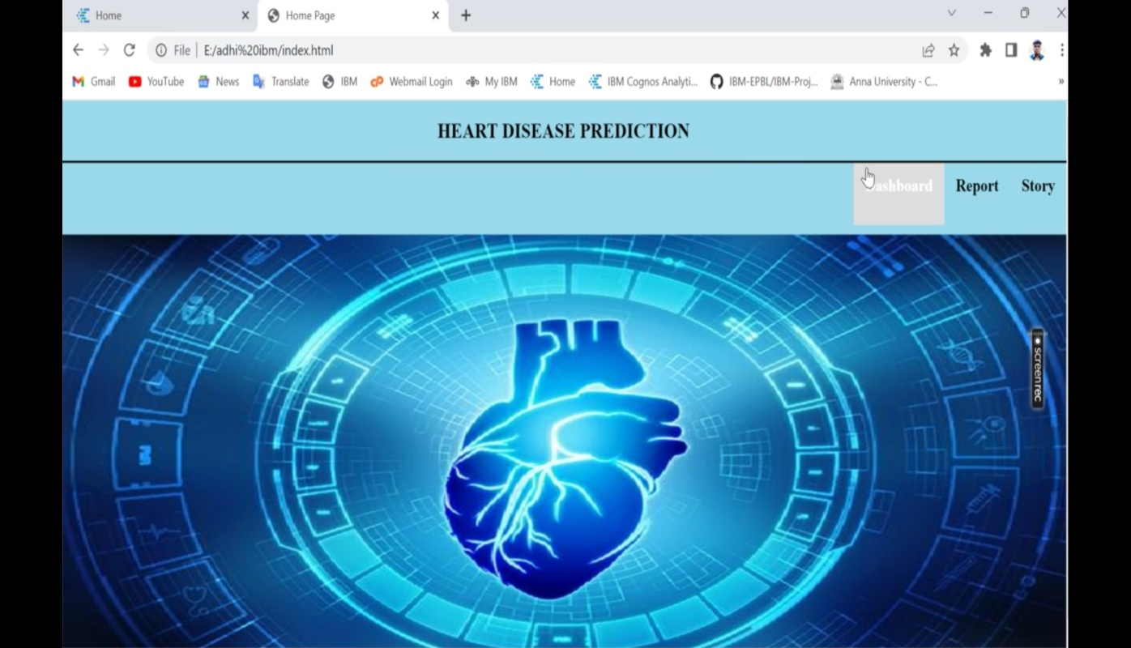

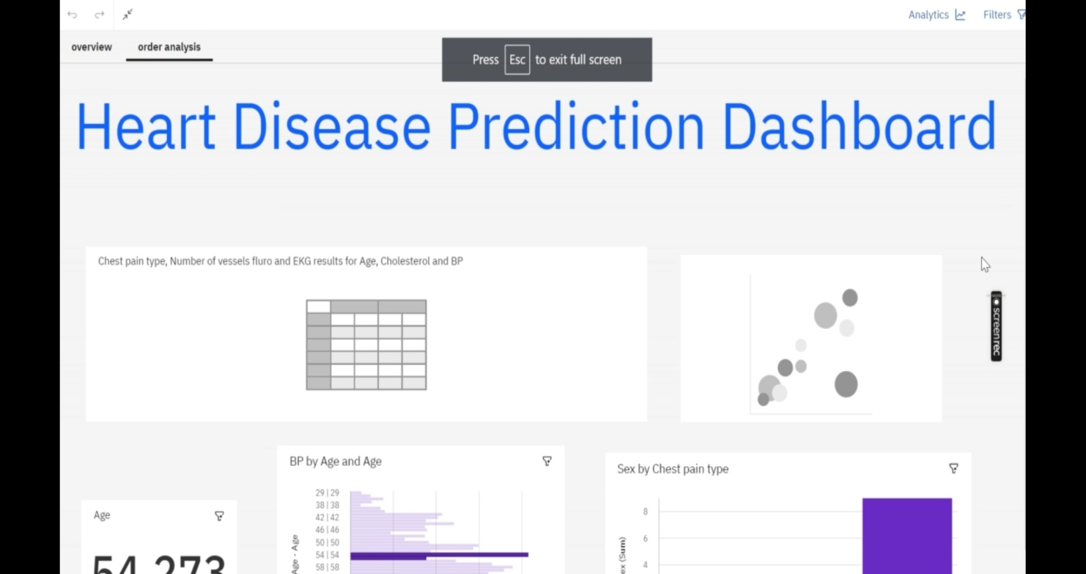

## Screenshot_2022-11-20-00-29-00-27_2768c6f3dd71c987876b7b9730ce2453.jpg

## 10.ADVANTAGES

1. Increased accuracy for effective heart disease diagnosis.
2. Handles roughest(enormous) amount of data using random forest algorithm and feature s
3. Reduce the time complexity of doctors.
4. Cost effective for patients.

## DISADVANTAGES

1. Prediction of cardiovascular disease results is not accurate.
2. Data mining techniques does not help to provide effective decision making.
3. Cannot handle enormous datasets for patient records.

## 11.SCOPE:

Here the scope of the project is that integration of clinical decision support with computer-based patient records could reduce medical errors, enhance patient safety, decrease unwanted practice variation, and improve patient outcome.

This suggestion is promising as data modeling and analysis tools, e.g., data mining, have the potential to generate a knowledge-rich environment which can help to significantly improve the quality of clinical decisions

## 12.CONCLUSION

Project introduction is the first step in building a system. Basically it will tell what is the application or a system That we are intended to build what it will look like, brief

describe on the proposed project, setting up the project Scope , defining project objective, problem statement of the project and also expected outcome. This stage will be Used as a reference to ensure system meet the project scope and project objective.

Heart attack is vital health hassle in human society. This paper has summarized kingdom of art technique and to be Had techniques for prediction of this sickness.

Deep studying an raising region of artificial intelligence showed a Few promising bring about different area of clinical diagnose with excessive accuracy .It continues to be an open Area waiting to get applied in heart disease prediction. Some strategies of deep studying has been discussed which May be implemented for heart disease prediction, alongside pioneer machine getting to know algorithms. An analytical assessment has been completed for locating out best available algorithm for clinical dataset. In Future our purpose is to carry ahead the work of temporal scientific dataset, where in dataset varies with time and Retraining of dataset is needed

**13.APPENDIX**

|  |
| --- |
| **GitHub & Project Demo Link** |
| **GITHUB LINK: https://github.com/IBM-EPBL/IBM-Project-40975-1660638167** |
| **DEMO LINK: https://photos.app.goo.gl/xVvUt63k1SHe1mQs5** |